ATARI BREAKOUT GAME - DOCUMENTATION

Table of Contents
- Flowchart of Logic
- Interrupt Usage
- Scoring and Gameplay Explanation

1. Flowchart of Logic
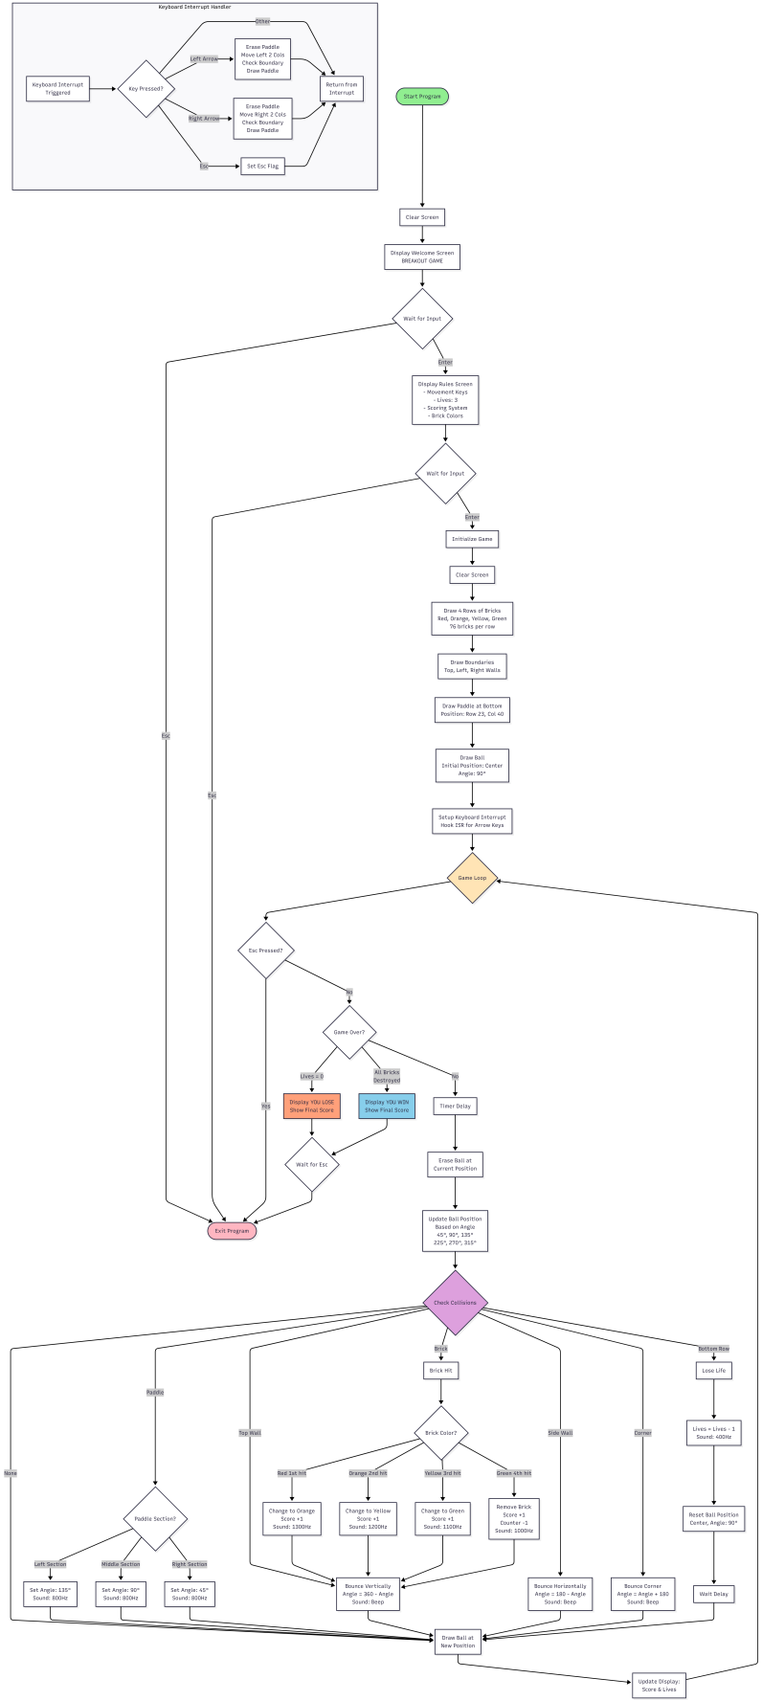

2. Interrupt Usage

A. Interrupt 9h - Keyboard Hardware Interrupt

Purpose
Handles real-time paddle movement without blocking game execution. This allows the paddle to respond immediately to arrow key presses while the ball continues moving.

Implementation Details
Hooking the Interrupt:
; Save original ISR address
xor ax, ax
mov es, ax
mov ax, [es:9*4] ; Get offset of original ISR
mov [oldIsr], ax
mov ax, [es:9*4+2] ; Get segment of original ISR
mov [oldIsr+2], ax

; Install new ISR
cli ; Disable interrupts during modification
mov word [es:9*4], paddleMove
mov [es:9*4+2], cs
sti ; Re-enable interrupts
ISR Handler (paddleMove):
paddleMove:
pusha ; Save all registers
push ds
push es

in al, 0x60 ; Read scan code from port 60h

cmp al, 0x01 ; Check for Esc (scan code 01h)
je esccode

cmp al, 0x4B ; Left Arrow scan code
je key_left

cmp al, 0x4D ; Right Arrow scan code
je key_right

jmp nomatch ; Chain to original ISR

key_left:
call erasePaddle ; Erase paddle at current position
sub di, 4 ; Move left by 4 bytes (2 columns)
call CheckBoundaryforPaddle ; Ensure within bounds
call printPaddle ; Redraw at new position

key_right:
call erasePaddle ; Erase paddle at current position
add di, 4 ; Move right by 4 bytes (2 columns)
call CheckBoundaryforPaddle ; Ensure within bounds
call printPaddle ; Redraw at new position

esccode:
mov byte [escCheckflag], 1 ; Set flag to exit game

nomatch:
pop es
pop ds
popa
jmp far [oldIsr] ; Chain to original ISR

Key Features
- Non-blocking: Game continues while waiting for input
- Immediate response: Paddle moves as soon as key is pressed
- Boundary checking: Prevents paddle from moving outside game area (positions 3682-3826)
- Chaining: Calls original ISR to maintain system functionality
- Register preservation: All registers saved/restored to prevent corruption

Scan Codes Used
- 0x01 - Esc key (exit game)
- 0x4B - Left Arrow (move paddle left)
- 0x4D - Right Arrow (move paddle right)

B. Interrupt 10h - BIOS Video Services

Purpose
Used for screen clearing and video mode operations during initialization.

Usage in Code
clrscr:
mov ax, 0xb800 ; Video memory segment
mov es, ax
mov ax, 0x0720 ; Space character with gray attribute
mov cx, 2000 ; 80×25 = 2000 characters
rep stosw ; Fill entire screen
Service Used:
- Direct video memory manipulation at segment 0xB800
- Each character cell = 2 bytes (character + attribute)
- Total screen size = 4000 bytes (2000 characters)

C. Interrupt 16h - BIOS Keyboard Services

Purpose
Used for waiting for specific key presses on welcome and rules screens.

Implementation
EnterorEsc:
tryagain:
mov ah, 0 ; Service 0 - Read keystroke
int 0x16 ; Wait for key press

cmp al, 13 ; Check for Enter (ASCII 13)
je enterPressed

cmp al, 27 ; Check for Esc (ASCII 27)
je escPressed

jmp tryagain ; Wait for valid key
Services Used:
- AH = 0: Wait for keystroke and read (blocking call)
- Returns: AL = ASCII character, AH = scan code

D. Speaker/Timer Interrupts - Sound Effects

Purpose
Generates audio feedback for game events using the PC speaker and timer.

Implementation
soundeffect:
mov bx, [bp+4] ; Get frequency from stack

; Calculate timer divisor
mov ax, 34DCh ; Timer frequency constant
mov dx, 12h
div bx ; Divisor = 1193180 / frequency

; Program timer channel 2
mov bx, ax
out 42h, al ; Send low byte
mov al, bh
out 42h, al ; Send high byte

; Turn on speaker
in al, 61h
or al, 00000011b ; Set bits 0 and 1
out 61h, al

call Timer ; Duration delay

; Turn off speaker
in al, 61h
and al, 11111100b ; Clear bits 0 and 1
out 61h, al

Sound Events
Event | Frequency | Description
Ball hits paddle | 800 Hz | Medium tone
Corner collision | 900 Hz | Slightly higher tone
Green brick breaks | 1000 Hz | High tone
Yellow brick hit | 1100 Hz | Higher tone
Orange brick hit | 1200 Hz | Even higher tone
Red brick hit | 1300 Hz | Highest tone
Lose life | 400 Hz | Low warning tone

Hardware Ports Used
- Port 42h: Timer channel 2 (PC speaker)
- Port 61h: System control port (speaker enable)

E. Interrupt 21h - DOS Services

Purpose
Used for program termination.

Implementation
; Exit program
mov ax, 0x4C00 ; Service 4Ch - Terminate with return code
int 21h ; Return to DOS
Service Used:
- AH = 4Ch: Terminate program with return code in AL

3. Scoring and Gameplay Explanation

A. Game Initialization

Starting Conditions
- Lives: 3 (displayed as hearts in upper right corner)
- Score: 0 (displayed in upper left corner)
- Ball Position: Center of screen (offset 3604)
- Ball Angle: 90° (straight up)
- Paddle Position: Row 23, Column 40 (offset 3760)
- Total Bricks: 304 (76 bricks × 4 rows)

Brick Layout
Row 1: RRRRRR... (76 Red bricks) - 4 hits to break
Row 2: OOOOOO... (76 Orange bricks) - 3 hits to break
Row 3: YYYYYY... (76 Yellow bricks) - 2 hits to break
Row 4: GGGGGG... (76 Green bricks) - 1 hit to break

B. Scoring System

Points Allocation
Every brick hit awards 1 point, regardless of brick color or hit number.

Brick Hit Progression
- Red Brick (0x04DB):
  - 1st hit → Changes to Orange → Score +1
  - 2nd hit → Changes to Yellow → Score +1
  - 3rd hit → Changes to Green → Score +1
  - 4th hit → Destroyed → Score +1
  - Total: 4 points per red brick
- Orange Brick (0x0CDB):
  - 1st hit → Changes to Yellow → Score +1
  - 2nd hit → Changes to Green → Score +1
  - 3rd hit → Destroyed → Score +1
  - Total: 3 points per orange brick
- Yellow Brick (0x0EDB):
  - 1st hit → Changes to Green → Score +1
  - 2nd hit → Destroyed → Score +1
  - Total: 2 points per yellow brick
- Green Brick (0x0ADB):
  - 1st hit → Destroyed → Score +1
  - Total: 1 point per green brick

Maximum Possible Score
- Red row: 76 bricks × 4 points = 304 points
- Orange row: 76 bricks × 3 points = 228 points
- Yellow row: 76 bricks × 2 points = 152 points
- Green row: 76 bricks × 1 point = 76 points
- Total Maximum Score: 760 points

C. Lives System

Starting Lives
Players begin with 3 lives, represented by hearts (♥) in the upper right corner.

Losing Lives
A life is lost when:
- Ball touches the bottom row (character 0x6078)
- Ball passes below the paddle without being hit

Life Loss Sequence
- Detect ball collision with bottom row
- Play 400 Hz warning sound
- Decrement health counter by 1
- Reset ball to center position (offset 3604)
- Reset ball angle to 90° (straight up)
- Pause briefly (Timer delay)
- Resume gameplay

Game Over Condition
When healthcounter reaches 0:
- Display "YOU LOSE" screen
- Show final score
- Set gameOverFlag = 1
- Exit game loop

D. Ball Physics and Movement

Ball Angles
The ball moves in 6 distinct angles (degrees):
Angle | Direction | Position Change
45° | Up-Right | -158 bytes
90° | Straight Up | -160 bytes
135° | Up-Left | -162 bytes
225° | Down-Left | +158 bytes
270° | Straight Down | +160 bytes
315° | Down-Right | +162 bytes

Position Calculation
Video memory position = (Row × 160) + (Column × 2)
- Each row = 80 characters × 2 bytes = 160 bytes
- Diagonal movement accounts for both row and column change

E. Paddle Mechanics

Paddle Size
6 characters wide (12 bytes in video memory)

Paddle Sections
The paddle is divided into 3 sections for angle control:
[ LEFT ][ MIDDLE ][ RIGHT ]
135° 90° 45°
When the ball hits:
- Left section (columns 0-1): Ball bounces at 135° (up-left)
- Middle section (columns 2-3): Ball bounces at 90° (straight up)
- Right section (columns 4-5): Ball bounces at 45° (up-right)
This gives players strategic control over ball direction.

Paddle Movement
- Left Arrow: Moves paddle 2 columns left
- Right Arrow: Moves paddle 2 columns right
- Boundary Limits:
  - Minimum position: 3682 (left wall)
  - Maximum position: 3826 (right wall)

F. Collision Detection

Collision Priority Order
- Top Wall (0x60C4): Vertical bounce
- Side Walls (0x60B3): Horizontal bounce
- Corners (0x60DA/BF/C0/D9): Diagonal bounce
- Paddle (0x07DF): Section-based angle change
- Bricks (0x04/0C/0E/0ADB): Damage brick, vertical bounce
- Bottom Row (0x6078): Lose life

Bounce Mechanics
Vertical Bounce (Top Wall):
New Angle = 360° - Current Angle
Example: 45° → 315°, 135° → 225°
Horizontal Bounce (Side Walls):
New Angle = 180° - Current Angle
Example: 45° → 135°, 315° → 225°
Corner Bounce:
New Angle = Current Angle + 180° (mod 360°)
Example: 45° → 225°, 90° → 270°

G. Win Condition

Victory Requirements
- All 304 bricks must be destroyed
- Tracked by BrickerCounter variable
- Initialized to 304, decrements when green bricks are destroyed

Win Sequence
- BrickerCounter reaches 0
- Display "YOU WIN" screen
- Show final score
- Set gameOverFlag = 1
- Exit game loop

H. Game Speed

Timer Control
Game speed is controlled by the Timer function:
Timer:
mov cx, 10000
loop:
add cx, 3 ; Waste cycles
dec cx
cmp cx, 0
jne loop

Ball Update Rate
- 4 timer delays per ball movement
- Creates smooth animation at appropriate speed
- Can be adjusted by changing timer loop count

I. Display Updates

Real-time Display Elements
Score Display (Top Left):
Score: XXX
- Updated after every brick hit
- Displayed in bright red (0x0C)
Lives Display (Top Right):
♥ ♥ ♥
- Hearts represent remaining lives
- Updated when life is lost
- Displayed in bright red (0x0C)

Update Frequency
- Score and lives updated every game loop iteration
- Ensures player always sees current game state

J. Control Summary
Key | Action
Enter | Continue from Welcome/Rules screen
Esc | Exit game at any time
Left Arrow (←) | Move paddle left
Right Arrow (→) | Move paddle right
Note: Arrow keys use keyboard interrupt for real-time response, while Enter/Esc use polling on menu screens.

Summary
This Atari Breakout implementation features:
- Real-time input via keyboard interrupts
- Progressive difficulty through multi-hit brick system
- Strategic gameplay with paddle section-based ball control
- Audio feedback for all game events
- Complete scoring system with maximum 760 points possible
- Classic arcade feel with smooth physics and responsive controls
The game successfully demonstrates advanced assembly programming concepts including interrupt handling, collision detection, video memory manipulation, and sound generation.

